Northwest Arkansas Metropolitan Fire Chiefs Association
Regional Mutual Aid Coordinator (RMAC)
Position Description and Purpose
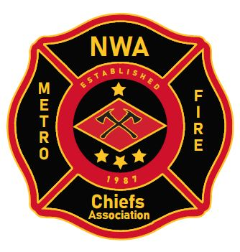
The purpose of the Regional Mutual Aid Coordinator (RMAC) is to:
- Provide resource management for area departments during incidents that deplete resources across a city or a region;
- Initiate the move-up of resources to fire stations during large incidents based on standard practice and protocol;
- Coordinate with area incident commanders to distribute finite resources appropriately;
- Manage area notifications to assemble incident management teams (IMTs) or improve situational awareness;
- Communicate with hospitals using technology about divert status, incidents of mass casualty, or other situations potentially impacting area healthcare;
- Communicate with area chiefs and emergency managers using technology about incidents of significance, including updates;
- Perform other functions to support area coordination, communication, and incident response as required.
Responsibilities:
The normal day-to-day responsibilities of the position include monitoring the regional NWA Metro Fire Chiefs Active 911 account, listening to incidents in area cities on an AWIN radio to monitor their nature and potential to escalate, and maintain connection to a designated cellular device for communication in the region.
When large scale (1st alarm equivalent or greater) incidents occur that also have the potential to exhaust resources in a city or region, the RMAC will automatically begin a move-up process involving unaffected departments to the region of concern. This process will be in accordance with standard department protocol and area best practice.
The RMAC can also serve as a resource for area incident commanders and shift leaders for specialized incidents, unique resource needs, and other items.

Qualifications:
The minimum qualifications for a person to work as the NWA RMAC will be the following:
- This person will be a current member, in good standing, of the NWA Metro Fire Chiefs Association (NWAMFCA). Their attendance, accounting for excused absences shall be a minimum of 75% and they shall be recommended by their Chief of Department with approval of the Executive Committee of the NWAMFCA.
- Demonstrated incident command experience at a chief officer level
- NIMS 300 and 400 Certification
- Knowledge of area resources and points of contact
- Three years’ experience as a chief officer
The desired qualifications of the NWA RMAC include the following:
- Experience as a shift commander or battalion chief
- Completion of command and control courses from the National Fire Academy
- Experience at incidents of regional significance or presidentially-declared disasters
- Regular participant in the NWA Metro Fire Chiefs Operations Committee
Application and Selection Process:
Interesting candidates shall meet the minimum qualifications, as established by this document, and submit a letter of interest explaining their commitment to the position, normal availability each month, and incident command experience to the President of the Operations Committee of the NWA Metro Fire Chiefs. A resume or curriculum vita should accompany the document. This information is due by July 14, 2023.
The NWA Metro Fire Chiefs Operations Committee with review applications and make recommendations to the executive board of the NWA Metro Chiefs. A mandatory training session will be provided for all approved RMAC candidates prior to official appointment.

